Nonagonal Pyramid
# Source: AI Source: Provided by: [Data Path: Persons Table -> ID Column: 1, Name_En Column: Motasem Essam] -> From: [ChatGPT] on [7/25/2026]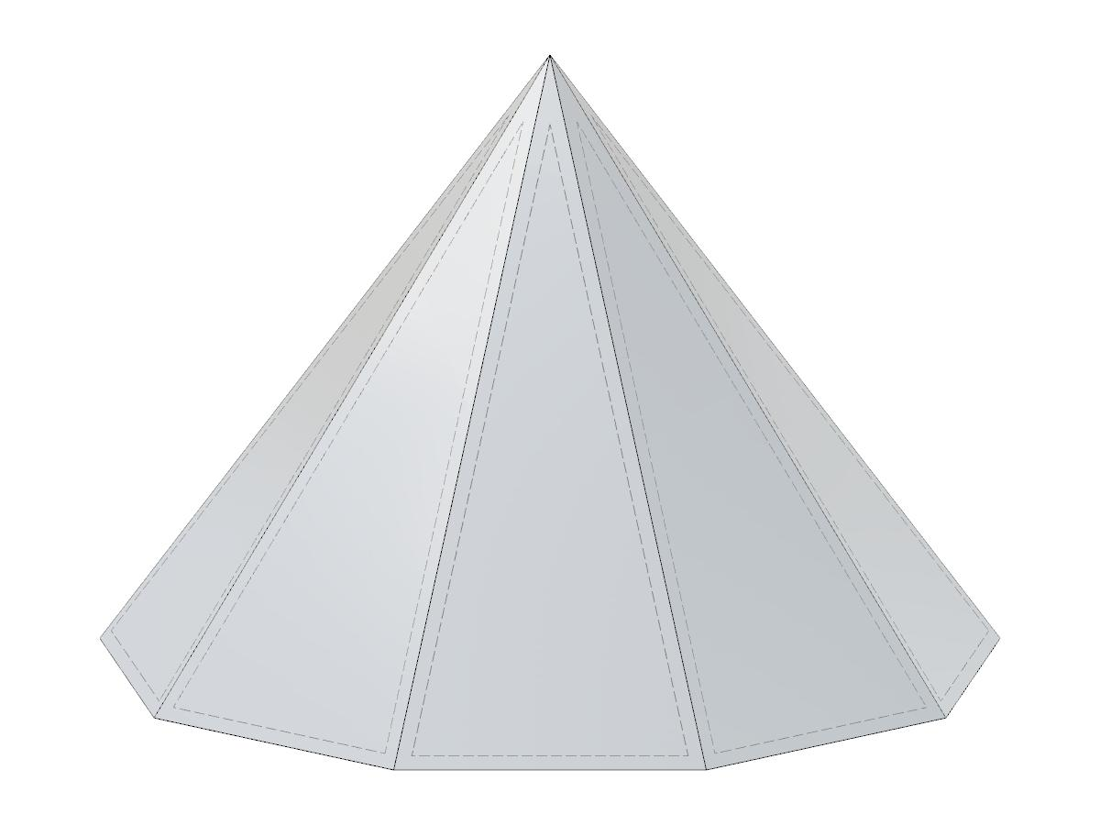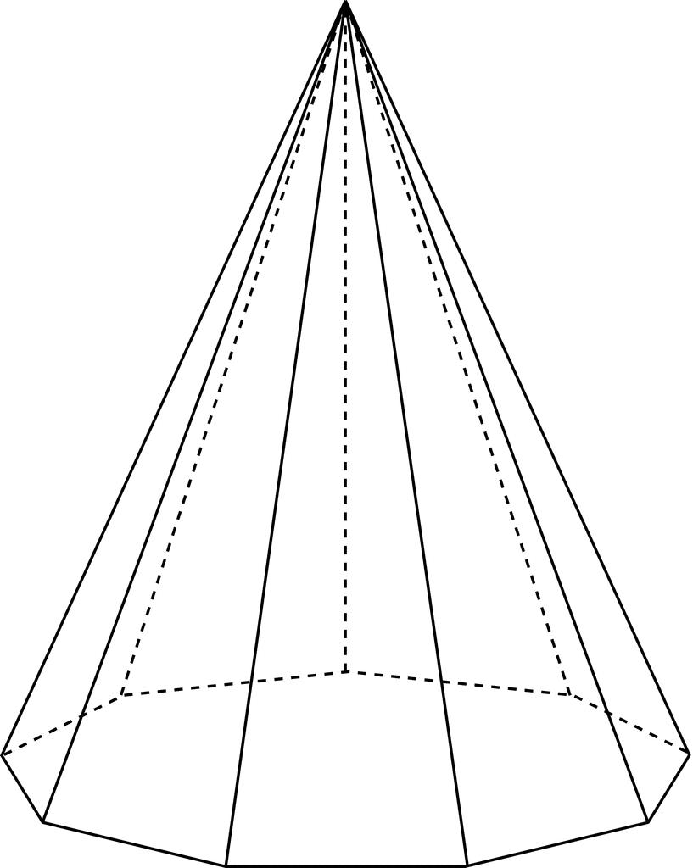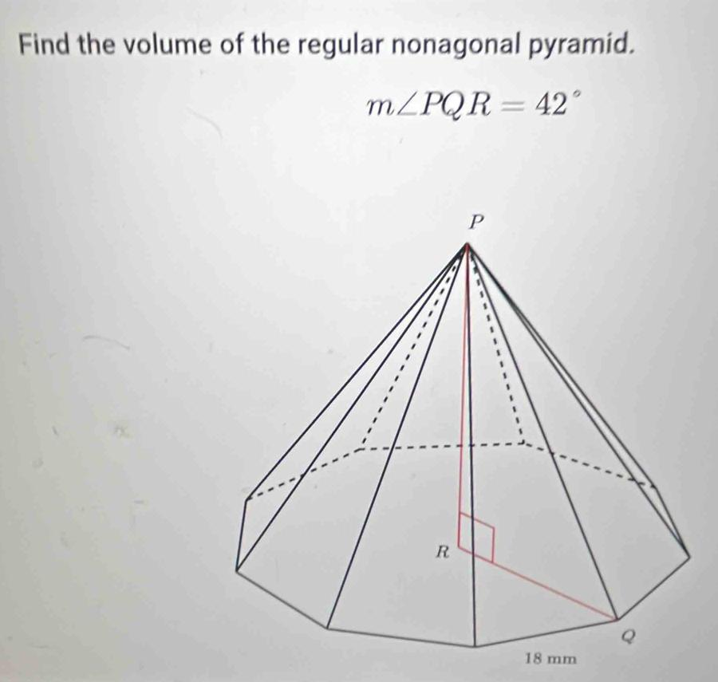

Definition
# Source: AI Source: Provided by: [Data Path: Persons Table -> ID Column: 1, Name_En Column: Motasem Essam] -> From: [ChatGPT] on [7/25/2026]
A Nonagonal Pyramid is a three-dimensional geometric solid with a nonagonal base (a polygon with nine sides) and nine triangular lateral faces that meet at a single common point called the apex.
The base can be a regular or irregular nonagon. Depending on the position of the apex, the pyramid can be right or oblique.

Simple Definition
# Source: AI Source: Provided by: [Data Path: Persons Table -> ID Column: 1, Name_En Column: Motasem Essam] -> From: [ChatGPT] on [7/25/2026]
A Nonagonal Pyramid is a solid with:
- One nine-sided polygon as its base.
- Nine triangular lateral faces.
- One apex where all nine triangular faces meet.

Classification Tree
# Source: AI Source: Provided by: [Data Path: Persons Table -> ID Column: 1, Name_En Column: Motasem Essam] -> From: [ChatGPT] on [7/25/2026]
Solid Geometry
└── Types of Solids
└── Pyramids
└── Types of Pyramids
└── Nonagonal Pyramid
├── Regular Nonagonal Pyramid
└── Irregular Nonagonal Pyramid
According to the position of the apex:
- Right Nonagonal Pyramid
- Oblique Nonagonal Pyramid

Key Characteristics
# Source: AI Source: Provided by: [Data Path: Persons Table -> ID Column: 1, Name_En Column: Motasem Essam] -> From: [ChatGPT] on [7/25/2026]
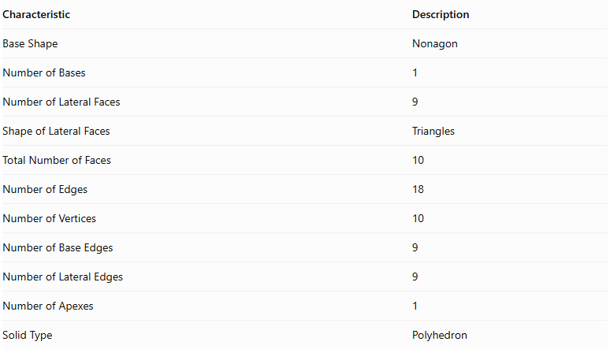
Characteristic | Description
Base Shape | Nonagon
Number of Bases | 1
Number of Lateral Faces | 9
Shape of Lateral Faces | Triangles
Total Number of Faces | 10
Number of Edges | 18
Number of Vertices | 10
Number of Base Edges | 9
Number of Lateral Edges | 9
Number of Apexes | 1
Solid Type | Polyhedron

Regular Nonagonal Pyramid
# Source: AI Source: Provided by: [Data Path: Persons Table -> ID Column: 1, Name_En Column: Motasem Essam] -> From: [ChatGPT] on [7/25/2026]
A Regular Nonagonal Pyramid has a regular nonagon as its base, with the apex directly above the center of the base in a right pyramid.
Its nine lateral faces are congruent isosceles triangles.

Geometric Representation
# Source: AI Source: Provided by: [Data Path: Persons Table -> ID Column: 1, Name_En Column: Motasem Essam] -> From: [ChatGPT] on [7/25/2026]
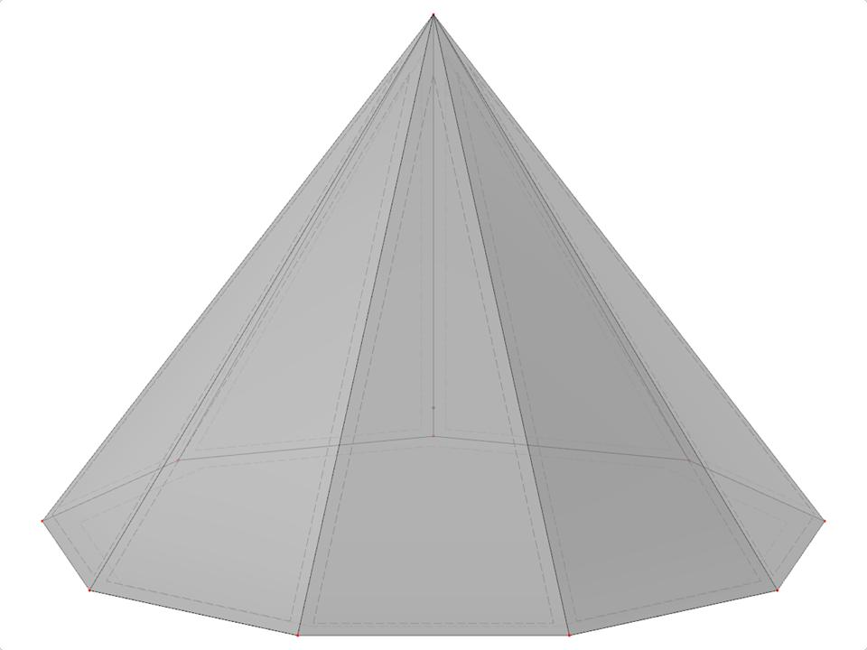

Main Components
# Source: AI Source: Provided by: [Data Path: Persons Table -> ID Column: 1, Name_En Column: Motasem Essam] -> From: [ChatGPT] on [7/25/2026]
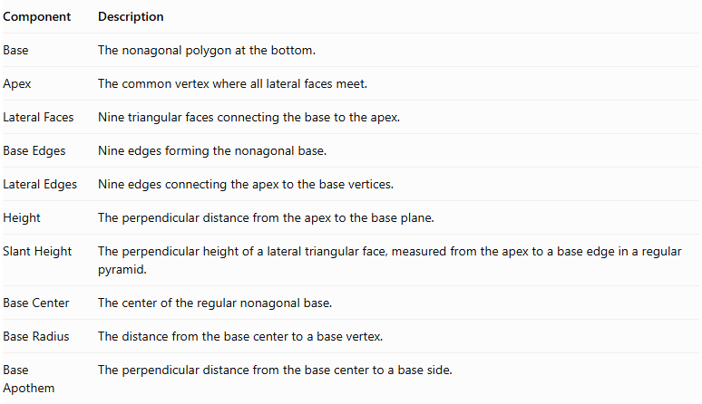
Component | Description
Base | The nonagonal polygon at the bottom.
Apex | The common vertex where all lateral faces meet.
Lateral Faces | Nine triangular faces connecting the base to the apex.
Base Edges | Nine edges forming the nonagonal base.
Lateral Edges | Nine edges connecting the apex to the base vertices.
Height | The perpendicular distance from the apex to the base plane.
Slant Height | The perpendicular height of a lateral triangular face, measured from the apex to a base edge in a regular pyramid.
Base Center | The center of the regular nonagonal base.
Base Radius | The distance from the base center to a base vertex.
Base Apothem | The perpendicular distance from the base center to a base side.

Mathematical Representations and Formulas
# Source: AI Source: Provided by: [Data Path: Persons Table -> ID Column: 1, Name_En Column: Motasem Essam] -> From: [ChatGPT] on [7/25/2026]
Let:
- $a$ = side length of the regular nonagonal base.
- $h$ = vertical height of the pyramid.
- $l$ = slant height of a lateral face.
- $r$ = apothem of the base.
- $R$ = circumradius of the base.
- $B$ = base area.
- $P$ = base perimeter.

A. Base Perimeter
# Source: AI Source: Provided by: [Data Path: Persons Table -> ID Column: 1, Name_En Column: Motasem Essam] -> From: [ChatGPT] on [7/25/2026]
For a regular nonagon:
$$P=9a$$

B. Base Area
# Source: AI Source: Provided by: [Data Path: Persons Table -> ID Column: 1, Name_En Column: Motasem Essam] -> From: [ChatGPT] on [7/25/2026]
$$B=\frac{1}{2}Pr$$
$$B=\frac{9ar}{2}$$
Using the side length directly:
$$B=\frac{9a^{2}}{4tan({20}^{∘})}$$

C. Base Apothem
# Source: AI Source: Provided by: [Data Path: Persons Table -> ID Column: 1, Name_En Column: Motasem Essam] -> From: [ChatGPT] on [7/25/2026]
$$r=\frac{a}{2tan({20}^{∘})}$$

D. Circumradius
# Source: AI Source: Provided by: [Data Path: Persons Table -> ID Column: 1, Name_En Column: Motasem Essam] -> From: [ChatGPT] on [7/25/2026]
$$R=\frac{a}{2sin({20}^{∘})}$$

E. Height and Slant Height
# Source: AI Source: Provided by: [Data Path: Persons Table -> ID Column: 1, Name_En Column: Motasem Essam] -> From: [ChatGPT] on [7/25/2026]
For a regular right nonagonal pyramid:
$$l=\sqrt{h^{2}+r^{2}}$$

F. Lateral Surface Area
# Source: AI Source: Provided by: [Data Path: Persons Table -> ID Column: 1, Name_En Column: Motasem Essam] -> From: [ChatGPT] on [7/25/2026]
The lateral surface consists of nine congruent triangular faces.
$$LSA=\frac{1}{2}Pl$$
$$LSA=\frac{9al}{2}$$

G. Total Surface Area
# Source: AI Source: Provided by: [Data Path: Persons Table -> ID Column: 1, Name_En Column: Motasem Essam] -> From: [ChatGPT] on [7/25/2026]
$$TSA=B+LSA$$
$$TSA=\frac{9ar}{2}+\frac{9al}{2}$$

H. Volume
# Source: AI Source: Provided by: [Data Path: Persons Table -> ID Column: 1, Name_En Column: Motasem Essam] -> From: [ChatGPT] on [7/25/2026]
$$V=\frac{1}{3}Bh$$
$$V=\frac{3arh}{2}$$

I. Number of Faces, Edges, and Vertices
# Source: AI Source: Provided by: [Data Path: Persons Table -> ID Column: 1, Name_En Column: Motasem Essam] -> From: [ChatGPT] on [7/25/2026]
For a pyramid with an $n$-sided base:
$$F=n+1$$
$$E=2n$$
$$V=n+1$$
For a Nonagonal Pyramid, $n=9$:
- Faces = 10
- Edges = 18
- Vertices = 10

Worked Examples

Example 1: Calculate the Number of Faces, Edges, and Vertices
# Source: AI Source: Provided by: [Data Path: Persons Table -> ID Column: 1, Name_En Column: Motasem Essam] -> From: [ChatGPT] on [7/25/2026]
Given:
$$n=9$$
Faces:
$$F=9+1=\boxed{10}$$
Edges:
$$E=2(9)=\boxed{18}$$
Vertices:
$$V=9+1=\boxed{10}$$

Example 2: Calculate the Base Perimeter
# Source: AI Source: Provided by: [Data Path: Persons Table -> ID Column: 1, Name_En Column: Motasem Essam] -> From: [ChatGPT] on [7/25/2026]
Given:
$$a=4 cm$$
$$P=9(4)$$
$$\boxed{P=36 cm}$$

Example 3: Calculate the Base Area
# Source: AI Source: Provided by: [Data Path: Persons Table -> ID Column: 1, Name_En Column: Motasem Essam] -> From: [ChatGPT] on [7/25/2026]
Given a regular nonagonal base with:
$$a=4 cm$$
$$B=\frac{9(4)^{2}}{4tan({20}^{∘})}$$
$$\boxed{B≈98.90{ cm}^{2}}$$

Example 4: Calculate the Volume
# Source: AI Source: Provided by: [Data Path: Persons Table -> ID Column: 1, Name_En Column: Motasem Essam] -> From: [ChatGPT] on [7/25/2026]
Given:
$$B=98.90{ cm}^{2}$$
$$h=12 cm$$
$$V=\frac{1}{3}(98.90)(12)$$
$$\boxed{V≈395.60{ cm}^{3}}$$

Example 5: Calculate the Lateral and Total Surface Areas
# Source: AI Source: Provided by: [Data Path: Persons Table -> ID Column: 1, Name_En Column: Motasem Essam] -> From: [ChatGPT] on [7/25/2026]
Given:
$$a=4 cm, l=8 cm$$
Perimeter:
$$P=9(4)=36 cm$$
Lateral surface area:
$$LSA=\frac{1}{2}(36)(8)$$
$$\boxed{LSA=144{ cm}^{2}}$$
Total surface area:
$$TSA=98.90+144$$
$$\boxed{TSA≈242.90{ cm}^{2}}$$

Comparison with Related Pyramids
# Source: AI Source: Provided by: [Data Path: Persons Table -> ID Column: 1, Name_En Column: Motasem Essam] -> From: [ChatGPT] on [7/25/2026]
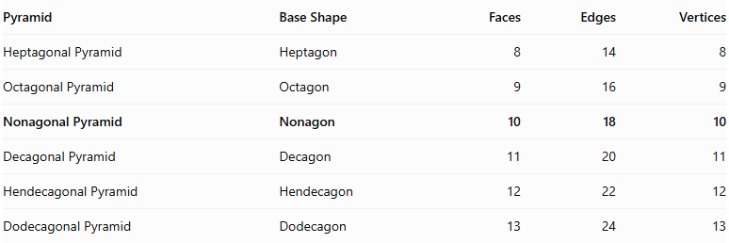
Pyramid | Base Shape | Faces | Edges | Vertices
Heptagonal Pyramid | Heptagon | 8 | 14 | 8
Octagonal Pyramid | Octagon | 9 | 16 | 9
Nonagonal Pyramid | Nonagon | 10 | 18 | 10
Decagonal Pyramid | Decagon | 11 | 20 | 11
Hendecagonal Pyramid | Hendecagon | 12 | 22 | 12
Dodecagonal Pyramid | Dodecagon | 13 | 24 | 13

Constructing Nonagonal Pyramid in Solid Geometry

Instruments Used
# Source: AI Source: Provided by: [Data Path: Persons Table -> ID Column: 1, Name_En Column: Motasem Essam] -> From: [ChatGPT] on [7/25/2026]
The construction uses physical geometric drawing instruments rather than coordinate-based methods.
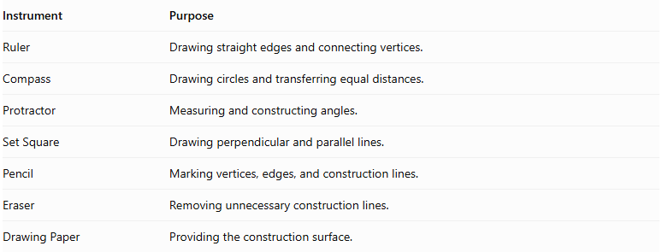
Instrument | Purpose
Ruler | Drawing straight edges and connecting vertices.
Compass | Drawing circles and transferring equal distances.
Protractor | Measuring and constructing angles.
Set Square | Drawing perpendicular and parallel lines.
Pencil | Marking vertices, edges, and construction lines.
Eraser | Removing unnecessary construction lines.
Drawing Paper | Providing the construction surface.

Construction Procedures

Base-Based Construction
# Source: AI Source: Provided by: [Data Path: Persons Table -> ID Column: 1, Name_En Column: Motasem Essam] -> From: [ChatGPT] on [7/25/2026]
- Draw a nonagonal base using a ruler, compass, and protractor.
- Identify and mark its nine vertices.
- Determine the position of the apex above or away from the base.
- Connect the apex to each of the nine base vertices.
- Complete the nine triangular lateral faces.
- Darken the visible edges and use dashed lines for hidden edges.

Apex-Based Construction
# Source: AI Source: Provided by: [Data Path: Persons Table -> ID Column: 1, Name_En Column: Motasem Essam] -> From: [ChatGPT] on [7/25/2026]
- Mark the intended apex position.
- Draw the nonagonal base beneath the apex.
- Identify the nine base vertices.
- Connect each base vertex to the apex.
- Complete the lateral triangular faces.

Vertex-Connection Construction
# Source: AI Source: Provided by: [Data Path: Persons Table -> ID Column: 1, Name_En Column: Motasem Essam] -> From: [ChatGPT] on [7/25/2026]
- Construct the nine vertices of the nonagonal base.
- Mark the apex as the tenth vertex.
- Connect the apex to all nine base vertices.
- Connect consecutive base vertices to complete the nonagonal base.
- Check that all edges and faces form a closed solid.

Edge-Based Construction
# Source: AI Source: Provided by: [Data Path: Persons Table -> ID Column: 1, Name_En Column: Motasem Essam] -> From: [ChatGPT] on [7/25/2026]
- Draw the nine edges of the nonagonal base.
- Determine the nine lateral edges extending from the base vertices to the apex.
- Construct and connect the lateral edges.
- Complete the triangular lateral faces.

Face-Based Construction
# Source: AI Source: Provided by: [Data Path: Persons Table -> ID Column: 1, Name_En Column: Motasem Essam] -> From: [ChatGPT] on [7/25/2026]
- Construct the nonagonal base.
- Draw nine triangular faces around the base.
- Connect the corresponding vertices and edges.
- Ensure that all nine triangular faces meet at the apex.

Net-Based Construction
# Source: AI Source: Provided by: [Data Path: Persons Table -> ID Column: 1, Name_En Column: Motasem Essam] -> From: [ChatGPT] on [7/25/2026]
- Draw one nonagonal base.
- Construct nine triangular faces around the nonagon.
- Add tabs if necessary for physical assembly.
- Cut out the net.
- Fold the triangular faces upward.
- Join their edges to form the nonagonal pyramid.
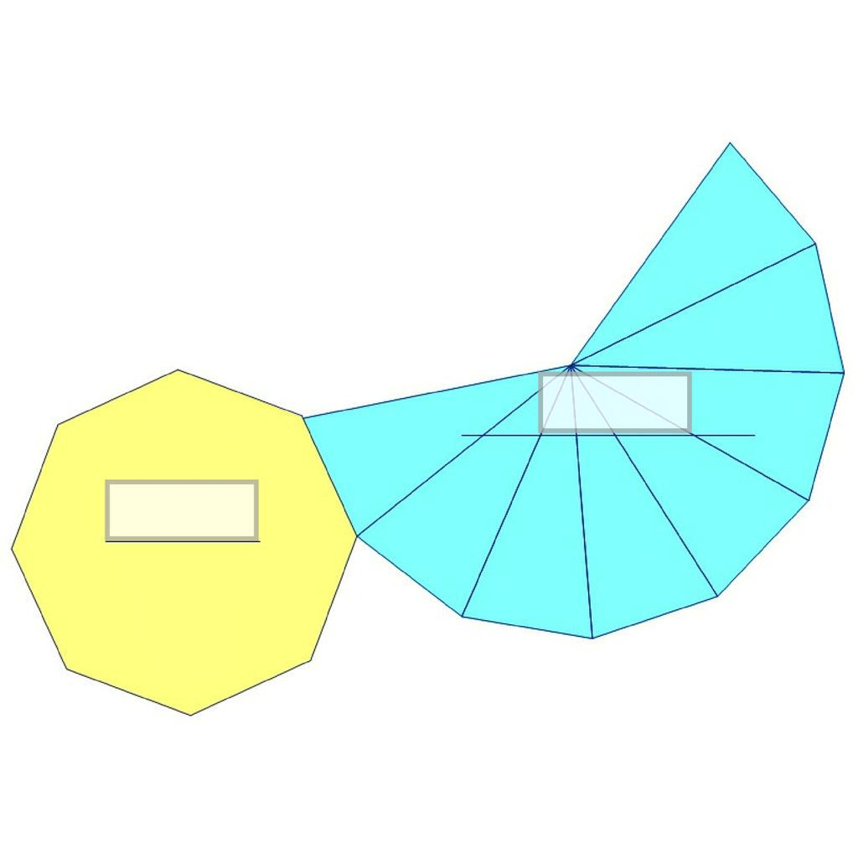

Applications
# Source: AI Source: Provided by: [Data Path: Persons Table -> ID Column: 1, Name_En Column: Motasem Essam] -> From: [ChatGPT] on [7/25/2026]
- Architecture: Decorative structures and roof designs with nonagonal bases.
- Mathematical Models: Teaching polygonal pyramids and three-dimensional geometry.
- Sculpture: Geometric sculptures and decorative objects.
- Engineering: Studying triangular face arrangements and structural geometry.

Key Points
# Source: AI Source: Provided by: [Data Path: Persons Table -> ID Column: 1, Name_En Column: Motasem Essam] -> From: [ChatGPT] on [7/25/2026]
- A Nonagonal Pyramid has one nonagonal base.
- It has nine triangular lateral faces.
- All nine lateral faces meet at one apex.
- It has 10 faces, 18 edges, and 10 vertices.
- Its volume is one-third of the product of its base area and perpendicular height.
- A regular right Nonagonal Pyramid has a regular nonagonal base and nine congruent isosceles triangular lateral faces.

Conclusion
# Source: AI Source: Provided by: [Data Path: Persons Table -> ID Column: 1, Name_En Column: Motasem Essam] -> From: [ChatGPT] on [7/25/2026]
A Nonagonal Pyramid is a polyhedron characterized by a nine-sided polygonal base and nine triangular lateral faces meeting at a single apex. It has 10 faces, 18 edges, and 10 vertices, making it an important member of the polygonal pyramid family.

